Student Name: Rajvir Slatch Date: Sept 20, 2022

**LAB: Working with Layer 2 and Layer 3 Network Devices**

**Directions:**

1. This lab is to be done during the class, the due date is Sept , 2022.
2. Answer only the questions in red colour.

**Learning Objectives:**

* Using Cisco Packet Tracer in physical and logical mode
* Organize the network devices on racks, using the network cabling according to the Topology Diagram.
* Learn how to create vlans
* Identify the differences between access ports and trunk ports
* Apply basic router configuration and learn how set up inter-vlan routing
* Configure and activate wan interfaces

# **Background / Scenario**

**Security Consultants Corporation** is a small company located in Toronto. The headquarters has 100 employees distributed in different floors of the building. Each year the main office hires 5 employers in average. The company will open a training centre for its new consultants and hired a network professional to enable communication with the main office.

A new network design engineer analyzed the network current conditions and found:

* The main wiring closet is located in the 3rd floor, has a bad cable management and is poorly labeled.
* There are 5 hubs distributed around the building. Most of the switches are out of warranty.
* There is a large broadcast domain that is affecting network performance. The end user always has complaints due to the network slowness.
* Sensitive information has high risk to be exposed.

# **Resources:**

- Cisco Packet Tracer

- switches Cisco 2960 Cisco IOS Release 15.0(2) lanbasek9 image.

- routers Cisco 2811 Cisco IOS Release 15.1 k9 c2800nm-advipservicesk9-mz

- PCs

- Select the appropriate media cabling (utp, fiber, cross-over, straight, console)

# **PART 1: Topology**

Configure the network topology in Cisco Packet Tracer using Physical Mode view.

1. In Physical Mode click and update the map labeling as Toronto.
2. Click on the map and label the main wiring room as Security Consultants Corporation

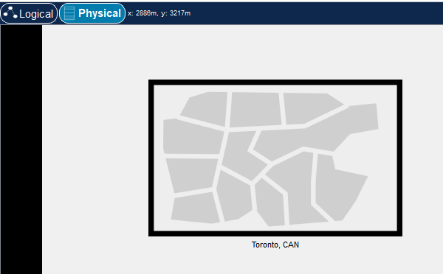

Building Map

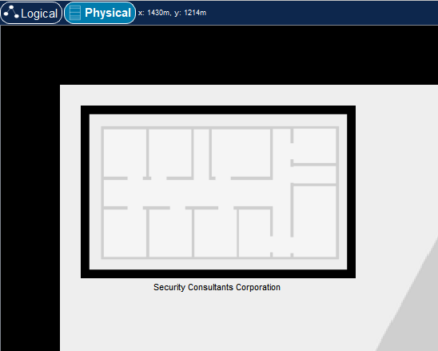

1. Click on the building map and on the Main wiring Closet.

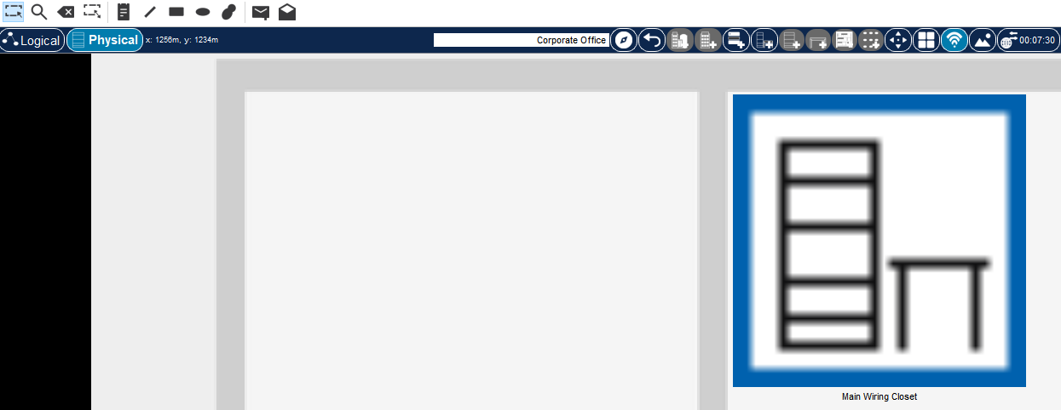

1. Install the rack by clicking in the icon shown in the graphic.

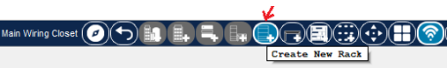

1. Create new table by clicking in the icon shown in the graphic.



1. Select 1 router, 2 switches and 3 pcs and move to the rack. Update the labels.

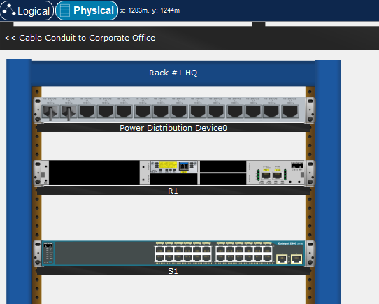

1. This is the Physical view of network devices installed on the rack.

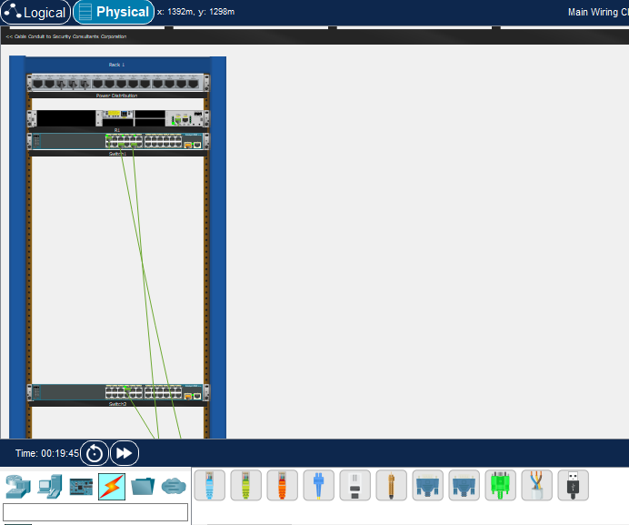

1. Go to Logical Mode and reorganize the network devices.
2. Install the card and SFP on each router. Before to install the card, turn off the device.

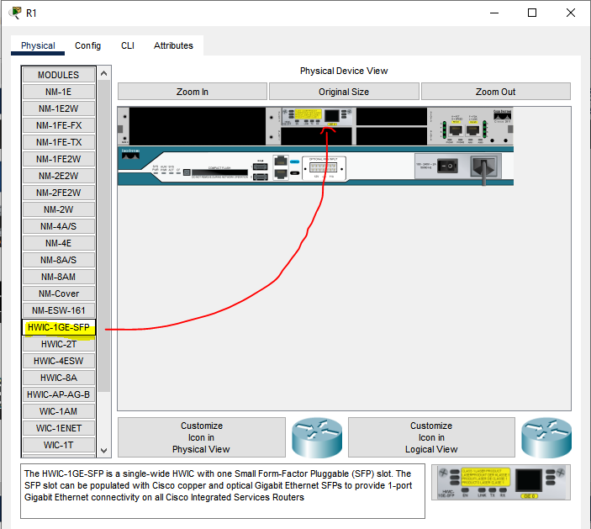

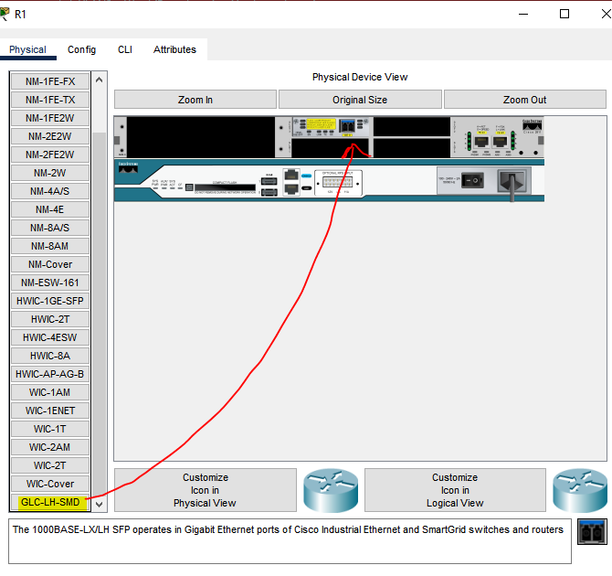

1. In Logical view mode cabling the network devices as shown in the topology.

Logical Topology

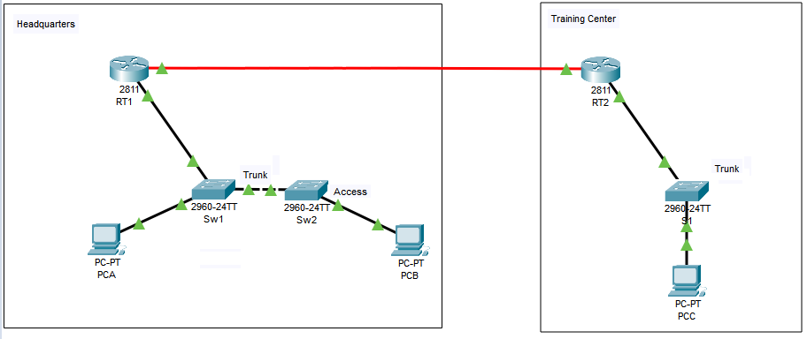

**NOTE:**

1. In this part of the lab, the network engineer wants to test the wan link between the headquarters and the new office.
2. Add a second building for the training center. Labeled as a Training Center

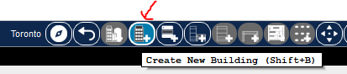

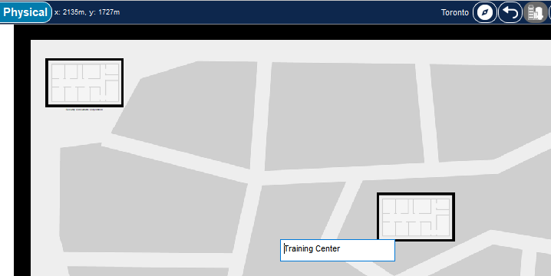

1. Add a new closet clicking on the icon shown:

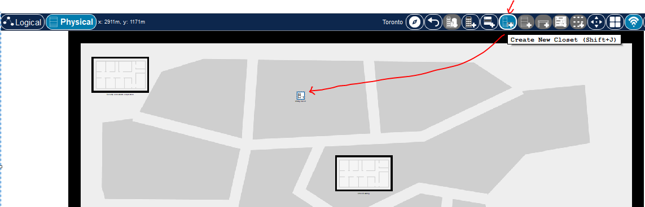

1. Drag and drop the closet to the building map.
2. Click on the closet and add 1 rack, 1 router and 1 switch.
3. Be sure to install the interface wan and SFP connector to the router.
4. Go the logical view, search and organize the new network devices.
5. Cabling using a fiber optic to connect both sites.

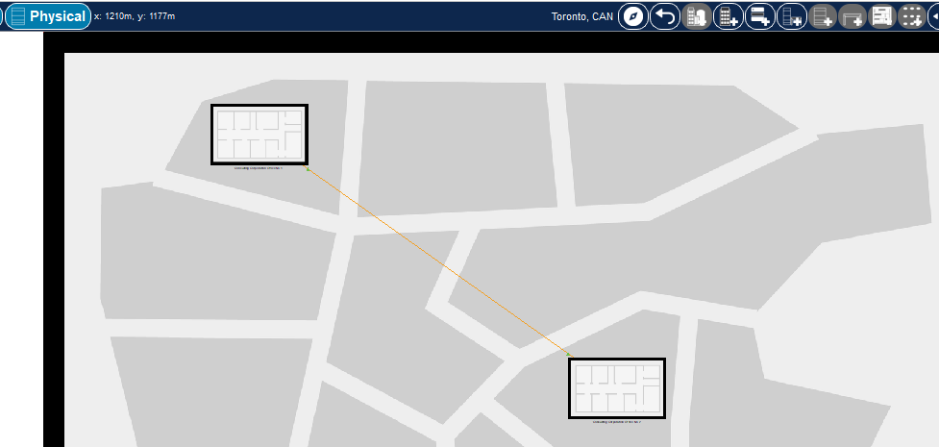

**PART 2: Basic End Device Configuration**

**Step 1:** Configuring the static ip address to PCs using the addressing table. Verify with ipconfig command using the command prompt window.

# **Addressing Table End Devices**

| Device | Interface | IP Address | Subnet Mask | Default Gateway | Connected to Network Device |
| --- | --- | --- | --- | --- | --- |
| PC-A | NIC | 172.17.40.21 | 255.255.255.0 | 172.17.40.1 | SW1 Fa0/1 |
| PC-B | NIC | 172.17.43.10 | 255.255.255.0 | 172.17.43.1 | SW2 Fa0/20 |
| PC-C | NIC | 192.168.10.11 | 255.255.255.0 | 192.168.10.1 | S1 Fa0/1 |

**PART 3: Basic Network Devices Configuration**

# **Step 1a):** Use Global Configuration mode to set up the router R1:

Router#conf t

Router(config)#

**Step 1b):** Copying and paste this information

ip domain-name cisco

hostname RT1

service password-encryption

enable secret class

banner motd #

Unauthorized access is strictly prohibited. #

line con 0

password cisco

login

logging synchronous

line vty 0 15

password cisco

exit

**Second Router**

ip domain-name cisco

hostname RT2

service password-encryption

enable secret class

banner motd #

Unauthorized access is strictly prohibited. #

line con 0

password cisco

login

logging synchronous

line vty 0 15

password cisco

exit

**Step 2:** Use Global Configuration mode to set up the switches S1 and S2 copying and paste this info:

**First switch**

no ip domain-lookup

hostname SW1

service password-encryption

enable secret class

banner motd #

Unauthorized access is strictly prohibited. #

line con 0

password cisco

login

logging synchronous

line vty 0 15

password cisco

logging synchronous

login

exit

**Second switch**

no ip domain-lookup

hostname SW2

service password-encryption

enable secret class

banner motd #

Unauthorized access is strictly prohibited. #

line con 0

password cisco

login

logging synchronous

line vty 0 15

password cisco

logging synchronous

login

exit

**Training Office First Switch**

no ip domain-lookup

hostname S1

service password-encryption

enable secret class

banner motd #

Unauthorized access is strictly prohibited. #

line con 0

password cisco

login

logging synchronous

line vty 0 15

password cisco

logging synchronous

login

exit

**PART 4: VLAN Configuration**

**Step 1 a):** Create the VLANs on switches:

SW1(config)# **vlan 40**

SW1(config-vlan)# **name Operations**

SW1(config-vlan)# **vlan 43**

SW1(config-vlan)# **name NetManagement**

SW1(config-vlan)# **end**

**Second switch SW2**

**vlan 40**

**name Operations**

**vlan 43**

**name NetManagement**

**Third switch S1**

**vlan 10**

**name Training**

**vlan 20**

**name Consultants**

**vlan 33**

**name NetManagement**

**end**

**Step 1: b)** Apply sh vlan brief in the Sw1 to know the current status of the vlans.

**Step 1: c)** What is the default VLAN? ___________

What ports are assigned to the default VLAN?

____________________________________________________________________________________

**Step 2a):** Move the switches IP address to VLAN management.

# **Addressing Table Network Devices Layer 2**

| Device | Interface | IP Address | Subnet Mask |
| --- | --- | --- | --- |
| SW1 | VLAN 43 | 172.17.43.4 | 255.255.255.0 |
| SW2 | VLAN 43 | 172.17.43.5 | 255.255.255.0 |
| S1 | VLAN 33 | 192.168.33.3 | 255.255.255.0 |

SW1(config)# **interface vlan 1**

SW1(config-if)# **no ip address**

SW1(config-if)# **interface vlan 43**

SW1(config-if)# **description Net Management**

SW1(config-if)# **ip address 172.17.43.4 255.255.255.0**

SW1(config-if)# **no shutdown**

SW1(config-if)# **end**

SW2(config)#

**interface vlan 1**

**no ip address**

**interface vlan 43**

**description Net_Management**

**ip address 172.17.43.5 255.255.255.0**

**no shutdown**

**end**

S1

**interface vlan 1**

**no ip address**

**interface vlan 33**

**description Net_Management**

**ip address 192.168.33.3 255.255.255.0**

**no shutdown**

**end**

**Step 2b):** What is the status of VLAN 43 in SW1? Apply Sh vlan brief and show ip int brief command.

Why?

____________________________________________________________________________________

**PART 5: Access Ports Configuration**

**Step 1:** Create access ports and assign them to the Vlans created earlier.

**SW1**

SW1(config)# **interface f0/1**

SW1(config-if-range)# **switchport mode access**

SW1(config-if-range)# **switchport access vlan 40**

SW1(config-if-range)# **no shutdown**

SW1(config-if-range)# **end**

SW1(config)# **interface range f0/2-24**

SW1(config-if-range)# **switchport mode access**

SW1(config-if-range)# **switchport access vlan 43**

SW1(config-if-range)# **end**

**SW2**

**interface f0/1**

**switchport mode access**

**switchport access vlan 40**

**no shutdown**

**interface range f0/2-23**

**switchport mode access**

**switchport access vlan 43**

**end**

**interface f0/20**

**switchport mode access**

**switchport access vlan 43**

**no shutdown**

**S1**

**interface f0/1**

**switchport mode access**

**switchport access vlan 10**

**no shutdown**

**interface range f0/2-9**

**switchport mode access**

**switchport access vlan 20**

**interface range f0/10-23**

**switchport mode access**

**switchport access vlan 33**

**end**

**Step 2 a):** In switch S1 verify the vlan status with sh vlan brief command.

**Step 2b): Default gateway in switches**

**SW1**

ip default-gateway 172.17.43.1

**SW2**

ip default-gateway 172.17.43.1

**S1**

ip default-gateway 192.168.33.1

**Step 3: Remove a vlan ID from the Vlan database**

**Step 3a):** In SW1 add vlan 50 to interface f0/05, using the next commands.

**SW1(config)#int f0/05**

**SW1(config-if)#switchport access vlan 50**

**Step 3b):** Print screen of the shown message.

**Step 3c):** Verify the vlan status with sh vlan brief command.

-What is the default name of VLAN 50?

**Step 3d):** Erase the vlan 50 applying the next command in global configuration mode and verify with sh vlan if the vlan 50 has disappeared.

**no vlan 50**

**end**

-What happens to the traffic destined to the host attached to F0/05?

**Step 4):** apply the next command:

**interface f0/05**

**no switchport access vlan**

**end**

- Discover with sh vlan brief the vlan assignment for the interface f0/05. Which VLAN is?

***NOTE:*** *Cisco recommends that before removing a VLAN from the database, reassign all the ports assigned to that VLAN.*

**PART 6: Trunk Ports Configuration between switches**

**Step 1a):** In switch 1, configure the interface Gigaethernet as trunk.

**SW1**

SW1(config)#int g0/1

SW1(config-if)#description TRUNK TO SW2

SW1(config-if)#switchport mode trunk

SW1(config-if)#switchport trunk allowed vlan 40,43

SW1(config-if)#no shutdown

SW1(config-if)#end

Additionally, set up the interface from SW1 to the Router.

**SW1**

interface FastEthernet0/24

description TRUNK TO RT1

switchport mode trunk

switchport trunk allowed vlan 40,43

no shutdown

**Step 1b):** In the second switch set up the interface Gig 0/1 as trunk.

**SW2**

int g0/1

description TRUNK TO SW1

switchport mode trunk

switchport trunk allowed vlan 40,43

no shutdown

end

**S1**

interface FastEthernet0/24  
description trunk to RT2  
switchport trunk allowed vlan 10,20,33  
switchport mode trunk

no shutdown

**Step 1c):** Use the command sh interface trunk to see the status of the interface.

**PART 7: Router Configuration**

**RT1**

interface FastEthernet0/0

description CONNECTED TO HQ LAN

no ip address

duplex full

speed 100

no shutdown

**RT2**

interface FastEthernet0/0

description TRAINING CENTER LAN

no ip address

duplex auto

speed auto

no shutdown

**PART 8: Inter-vlan routing or router on a stick**

**RT1**

interface FastEthernet0/0.40

encapsulation dot1Q 40

ip address 172.17.40.1 255.255.255.0

description LAN Operations

no shutdown

!

interface FastEthernet0/0.43

encapsulation dot1Q 43

ip address 172.17.43.1 255.255.255.0

description LAN NetManagement

no shutdown

**RT2**

interface fastethernet0/0.10

encapsulation dot1q 10

ip address 192.168.10.1 255.255.255.0

description LAN Training

no shutdown

interface fastethernet0/0.20

encapsulation dot1q 20

ip address 192.168.20.1 255.255.255.0

description LAN Consultants

no shutdown

interface fastethernet0/0.33

encapsulation dot1q 33

ip address 192.168.33.1 255.255.255.0

description LAN NetManagement

no shutdown

**PART 9: Configuring WAN interfaces**

**Step 1:** Configure ip addressing on GigabitEthernet0/3/0 and enable the interface.

# **Addressing Table Network Devices Layer 3 – WAN Link**

| Device | Interface | IP Address | Subnet Mask | Default Gateway |
| --- | --- | --- | --- | --- |
| RT1 | G0/3/0 | 192.168.2.1 | 255.255.255.252 | NA |
| RT2 | G0/3/0 | 192.168.2.2 | 255.255.255.252 | NA |

RT1(config-if)# int g0/3/0

RT1(config-if)# ip address 192.168.2.1 255.255.255.252

RT1(config-if)# description WAN Link to RT2

RT1(config-if)# no shutdown

**Step 2:** Copy the running configuration to the startup configuration.

RT1(config-if)# **end**

RT1# **copy run start**

**Step 3:** Configure ip addressing on GigabitEthernet0/3/0 and enable the interface.

RT2(config-if)# int g0/3/0

RT2(config-if)# ip address 192.168.2.2 255.255.255.252

RT2(config-if)# description WAN Link to RT1

RT2(config-if)# no shutdown

**Step 4:** Copy the running configuration to the start-up configuration.

RT1(config-if)# **end**

RT1# **copy run start**

**Step 5:** Verify the status of the interfaces in both routers and copy the result of the command.

RT1# sh ip interface brief

RT2# sh ip interface brief

**PART 10: Routing**

**Step 1:**

1. What kind of routing has the engineer been testing? Static or Dynamic?
2. What else do we need to configure in the routers to have connectivity from Headquarters to the Training Center?
3. Verify the routing table in each router using sh ip route command.

RT1#

RT2#

**Step 2: Testing (ping, ipconfig)**

1. Print the ipconfig of PCA, PCB and PCC.
2. Print screen the ping result from PCA to PCC.
3. Print screen the ping result from PCB to PCC.

Note: *If the ip route was configured well on the routers the traffic between the PCs should be successful. These apply if we want to all vlans traffic to be visible. Otherwise, we will only allow the specific traffic.*